Skill Level One
Drill #1: One Foot Runs
Alternately place one foot in each rung and concentrate on maintaining an upright posture. Concentrate on keeping the backward snap of the elbow in synch with feet; as the right elbow drives back, the right knee drives forward, and vice versa.
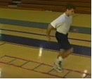
Drill #2: Two Foot Runs
This is the same as Drill #1, but this time, both feet must land in each square. The motion is shorter and faster than those used in the first drill. Make sure to perform equal repetitions leading with your right and left foot.
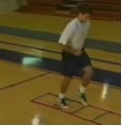
Drill #3: Brake Run
You start off using the same motion as one-foot runs. Then, at the half way point, switch to the motion of two-foot runs. Switching motions will give you the sensation of slamming on your brakes. You need to control your body and accelerate your feet and elbows, rather than losing control and falling forward.
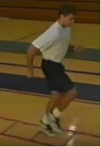
Drill #4: Hop Scotch
On this drill, you start with both feet inside the first rung. You then hop forward and land with a foot on either side of the second rung. This pattern is repeated along the length of the ladder. Concentrate on maintaining a low center of gravity, especially as the speed of the hops increase.
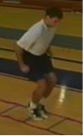
Drill #5: Backward Hop Scotch
This drill is performed exactly the same as Drill #4, but in reverse. Balance and rhythm are key to success on this move.
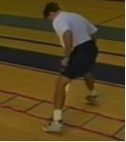
Drill #6: Lateral Run
In this drill, you start facing side-on with both feet in the first ladder rung. Both feet land in each square before moving on to the next square. As with all lateral drills, be sure to give equal attention to moving to your right and left.
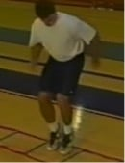
Drill #7: Rabbit Hops
Here you will hop into each ladder rung with both feet together. The emphasis here is on quickness off the ground rather than height.
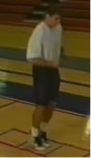
Drill #8: Jump Cuts
Jump Cuts are a great exercise for any athlete who competes in a sport that requires cutting in very limited space. The feet are kept together and alternately hop in and out of the ladder. Remember to keep the knees bent in order to absorb shock.
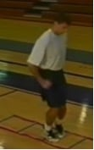
Drill #9: Ladder Skips
Skips on the ladder are an excellent drill for teaching sprint mechanics. Run through the ladder by placing one foot in each rung at a time. Concentrate on keeping the body upright and lifting the knee as high as you can. The dorsal flexion of the foot and the backward snap of the elbow need to be emphasized.
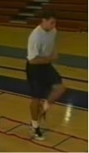
Drill #10: Scissor Skips
This skipping drill has your knees locked as you skip your way down the ladder. You use only the flip of the ankle to propel yourself forward. Make sure to keep the upper body in synch with the lower body.
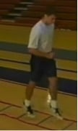
Skill Level Two
Drill #11: Icky Shuffle
This is one of the best drills that can be performed on the agility ladder. Start at the beginning of the ladder with your left foot in the ladder rung and your right foot outside it. Now move your left foot to the outside of the ladder and bring your right foot into it. Move down the ladder in this pattern, alternating feet as they come in and out of the ladder.
This move lays the ground work for a number of other drills. Once you master the basic pattern of this drill, lightning speed can be achieved by speeding up the sound of the feet.
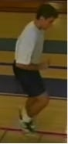
Drill #12: X-Country Skier Drill
Here you will move laterally in a motion similar to that of a cross-country skier. The lead foot begins in the first rung of the ladder. The trail foot is directly behind and outside the first rung. The feet quickly switch places as you move down the ladder.
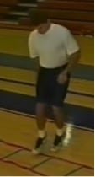
Drill #13: Straddle Hops
Straddle Hops places the athlete in a low wide base position, similar to a defensive football position. Imagine that your feet are locked about two feet apart. Straddle in and out of the ladder as you move down its length, alternately bringing a foot to the outside of the ladder. Ground contact should be light with the top of the foot.
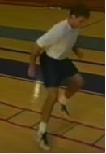
Drill #14: Double Step Icky Shuffle
This is an advanced form of the Icky Shuffle shown in Drill #11. It requires that you take one extra step. Instead of both feet touching in the middle and only one on the outside, here both feet are placed outside the ladder before coming back in.
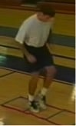
Drill #15: Single Square Buzzsaw
Moving laterally, step into the first square with your lead foot and then in with your back foot. You then exit the square in the same manner and move on to the next square.
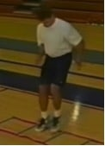
Drill #16: Wide Icky Shuffle
This is another variation of the Icky Shuffle, shown in Drill #11. This time you perform the move as in the original, but exaggerate the motion by moving wider outside the ladder and lifting the feet higher. This is a great drill for improving lateral change of direction speed.
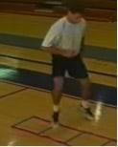
Cone Agility Drills
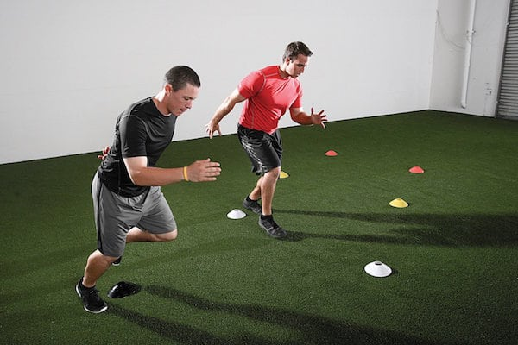
Drill #17: 5-10-5 Drill
Set up 2 cones, that are 10 yards apart. Place a third cone at the mid-point between them. Starting at the mid cone, sprint 5 yards to the right cone. Then sprint 10 yards all the way across to the left cone. Finish with a 5-yard sprint back to the middle. Be sure to touch each cone as you quickly change direction.
Drill #18: T-Drill
Set up the three cones as above, but place a fourth cone 10 yards from the middle cone, to make a 'T' formation.
Start at the fourth cone and sprint to the middle cone. Now side shuffle to the left cone. Sprint all the way across to the right cone. Side shuffle back to the middle cone. Finish by backpedaling to the start point.
Drill #19: Box Drill
Set up four cones in a square with sides of 10 yards. Start at the bottom right cone. Sprint to the top right cone. Now side shuffle to the top left cone. Backpedal to the bottom left cone. Finally, carioca (over, out, back, out) back to the start position.
Here is how to carioca: ​
Carioca Running Form Drill Demonstration
Drill #20: Modified Box Drill
Set up the cones as in the Box drill, but have a fifth cone in the middle of the square. Number the corner cones from 1 to 4. Begin at the middle cone. Have a coach call out a cone number. Sprint to that cone and then return to the middle to wait for the coach to call out another number.

